**ECE183DB: Storage Sub-System Testing Formulation**

Now that we have managed to set up the storage sub-system in the Webots environment, the next step is to test rigorously on the limitation of the system and optimize the actuators’ motion. Here is a list of tests that we will be doing for the storage sub-system:

1. **Tray position variation on a static vertical column:** This test directly corelates with the accuracy of the robotic arm dropping of the tray on the vertical column. Since it might not drop the tray exactly at the center, we want to know how far of the tray can be so that it can stay on top of the vertical column. This will be a static test and the steps would be:
   1. Vary the total mass of the tray: [4.5, 6, 8] in kg
   2. Vary the center of mass: [center, edge]
   3. Vary the rotation of the tray on the xy-plane: [0, 3, 5] in degrees
   4. CONSTANT: size of the vertical column platform
2. **Tray position variation on the vertical motion (going downward):** In this test, the main focus will see how fast the storage can move vertically without tipping the tray. We will test this with a subset of test condition from the Test 1, specifically on the different center of mass. The steps would be:
   1. Vary the vertical speed of the vertical column: [0.05, 0.1, 0.2, 0.4] in m/s
   2. CONSTANT: size of the platform on the vertical column, rotation of the tray, total mass of 10lb
3. **Kitchenware variation on the horizontal motion (going into storage area):** In this test, we want to see what speed we can achieve with the average height, mass, and kitchenware distribution on the tray
   1. Vary the speed of the horizontal motion: [0.1, 0.2, 0.4] in m/s
   2. Vary the height and amount of kitchenware on the tray to test inertia effect:
      1. Height: [6, 8, 10] in inches
      2. Plates: [1, 3, 5] in a mixture of plates and bowls
   3. CONSTANT: total mass of 10lb, rotation of the tray
4. **Operation time of storing the tray:** In this test, we want to observe, on average how fast we can store a tray based on the results of the first three tests.

Note that we will not be testing load capacity intensively to determine the force vertical column can withstand but rather to observe for possible tipping. The load capacity of the vertical column is way higher than the average mass in top of a full tray.

**Test 1**

|  |  |  |  |
| --- | --- | --- | --- |
| **Total mass (kg)** | **Center of mass (kg)** | **XY-rotation (degrees)** | **Observation** |
| 4.5 | center | 0 | The kitchenware stayed on top of the tray |
| 4.5 | edge | 5 | The kitchenware stayed on top of the tray. Slight vertical tilting when the simulation started |
| 6 | edge | 5 | The kitchenware stayed on top of the tray. However, tilting is now significant. We can see the other side of the tray being tilted up if there’s no weight, like plates or bowls, to counteract the variable weight of the cup |
| 8 | edge | 5 | The kitchenware tipped the tray and fell over. |

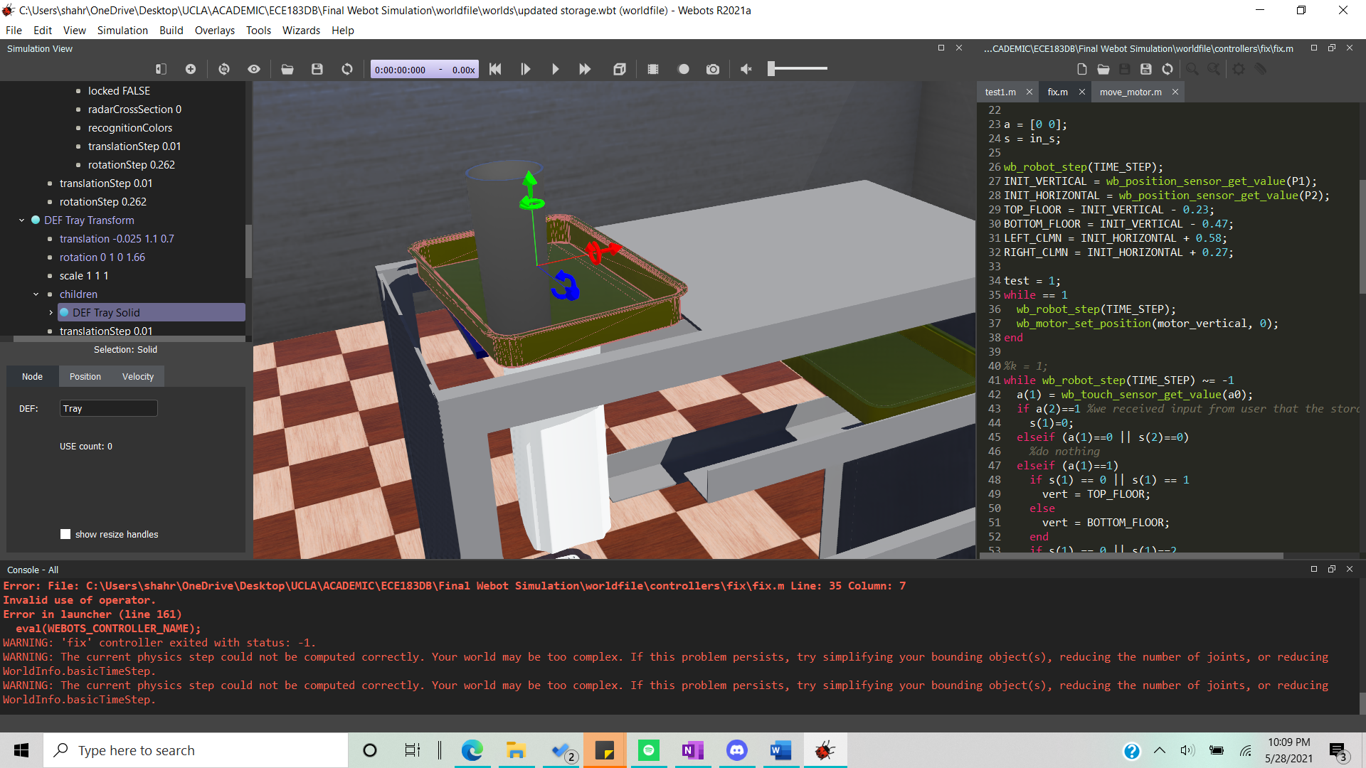

**Test 4**

For this test, we need to define a couple of velocity constant:

|  |  |
| --- | --- |
| Symbol | Description |
|  | This is the GENERAL speed that the actuators are going to operate in. This includes vertical column going down and up, and the horizontal actuator moving out of the storage area. |
|  | This is the INSERTION speed, which is the speed of the horizontal actuator moving into the storage area. This speed needs to be optimized in order to not make it too fast as to cause tipping of kitchenware on top of the carried tray. |
|  | The PLACEMENT speed. This is the speed of the vertical column when placing the tray onto the storage area |

|  |  |  |  |
| --- | --- | --- | --- |
|  |  |  | Operation Time Range (s) |
| 0.2 | 0.1 | 0.1 | 9 - 16 |

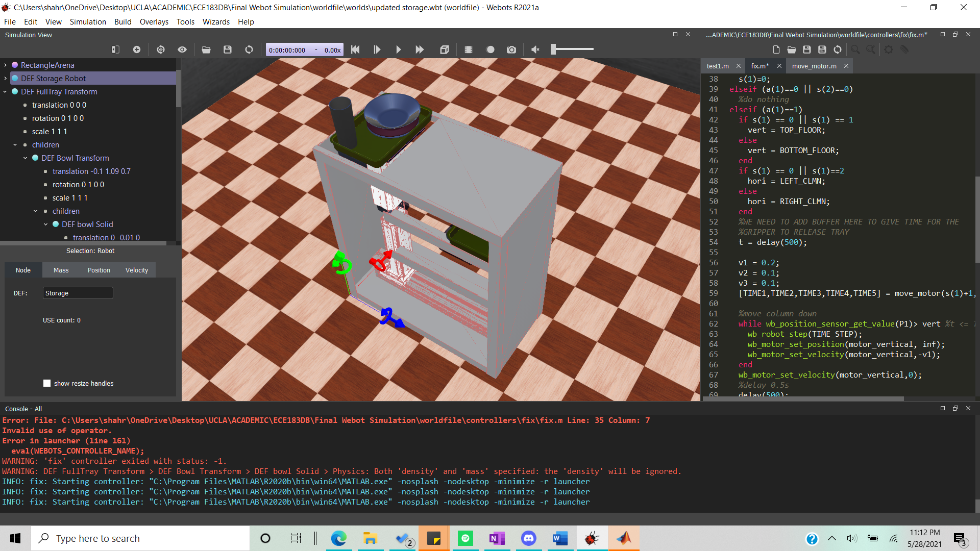

**ECE183DB: Team People Robotic Arm Sub-System Testing Formulation**

Testing the arm in Webots will prove to be challenging as the physics involve moving multiple objects simultaneously prove to be computationally challenging. Therefore, there will be limitation to what extend we can test the arm. However, here is the list of tests we have so far:

1. **Error in trajectory of the end effector:** Given the trajectory produced by the planning algorithm, we want to see, at each time step, how close the actual robot arm follows the trajectory. There could be deviation due to multiple factors like motor errors, bending, and physical interaction with other solids.
   1. In the test, we will not be using a tray. We will define an end effector as a position within the gripper and see how it evolves over time.
   2. Randomize trajectories will be put in as inputs and the actual motion of the arm will be observed.
   3. The trajectory will be observed at each time step.
2. **Gripping accuracy of the gripper of the arm**: To account for variability of the tray position on the table, we decided to implement a mechanical solution to account for that. That is, on the long edge, we have 5 inches of extra space for tray position variation. Assume that the long end is parallel to the edge we are facing (y-axis) and the short edge is perpendicular (x-axis). Usually, variation along these axes is assumed to be due to the accuracy of the robotic arm movement, given the position of the tray. However, in real life, there might be situation where the tray itself is not exactly aligned or positioned as seen by the camera detection system. Thus, with a non-perfect positioning, we want to see how strong this gripper can hold the tray in place. Here is what we will do
   1. Vary the position (x,y) and the rotation of the tray, with respect to the given tray position from the camera.
   2. Observe if the gripper mechanical design can still pick up the tray and hold it in place as it moves around.
3. **Final position of the tray:** The position on where the tray is dropped affect the effectiveness of the storage system to store the tray. Therefore, it is very crucial we ensure that this is accurate enough. In order to test this, we will do the following:
   1. Assume the tray is ideally placed on the table with a constant load
   2. Run the simulation through the trajectories
   3. Calculate the relative error of the final position of the tray based on the center of the vertical column platform.
4. **Tray load on the trajectory and end position:** Given a reasonable variation on the weight of the tray, we want to see how it will affect the trajectory motion and the final position of the tray when we drop it off. This is how we will do it:
   1. Keep the trajectory and the tray initial orientation constant
   2. Vary the mass and weight distribution of the tray: [5, 7.5, 10, 12.5, 15] in lbs.
   3. Observe the trajectory and the tray final position and orientation